**Assignment 1: Output**

* Log in as “Admin” and go to “Employee System” and input 1 to check “Manager worker”.

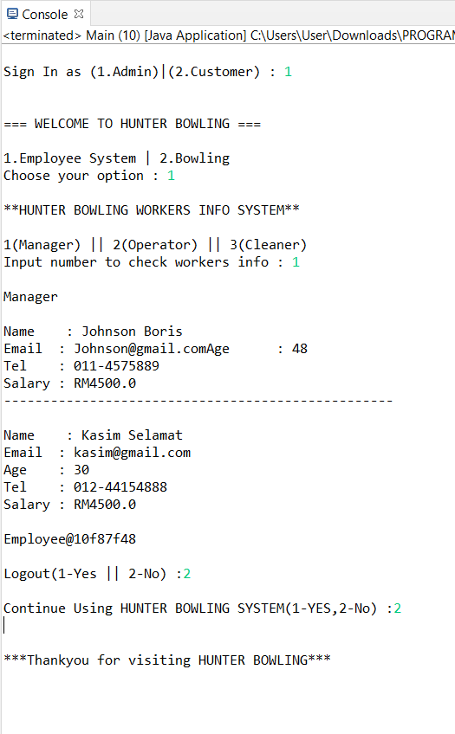

* Log in as “Admin” and go to “Employee System” and input 2 to check “Operator worker”.

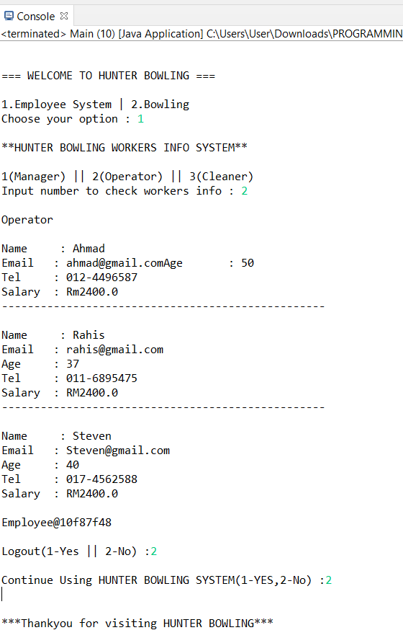

* Log in as “Admin” and go to “Employee System” and input 3 to check “Cleaner worker”.

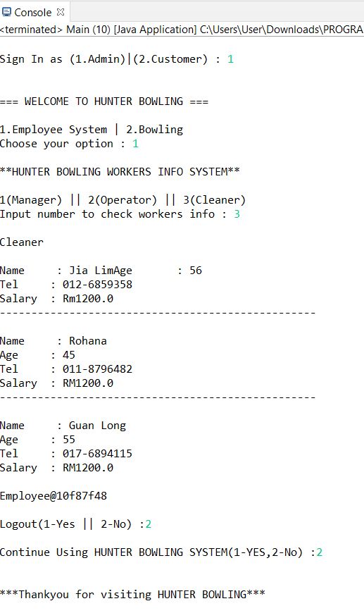

* Log in as “Admin” and go to “Bowling Info”

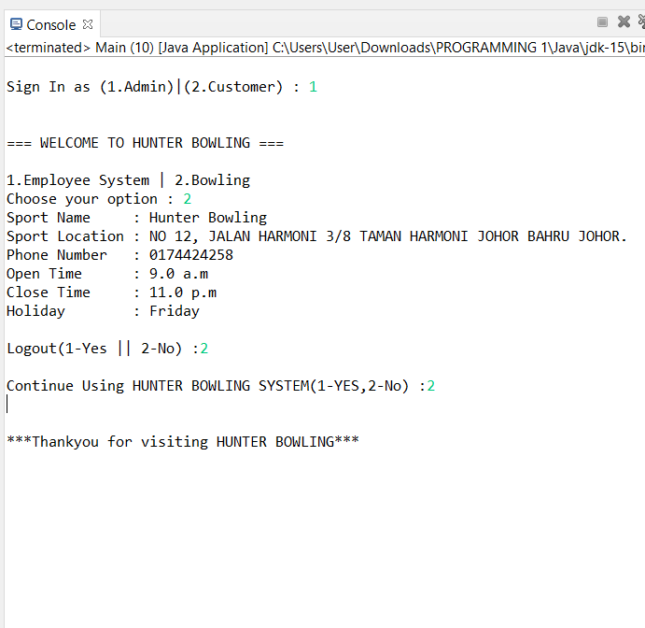

* Log in as “Customer” and go to “Membership Registration” and choose “member card type” that want to register.

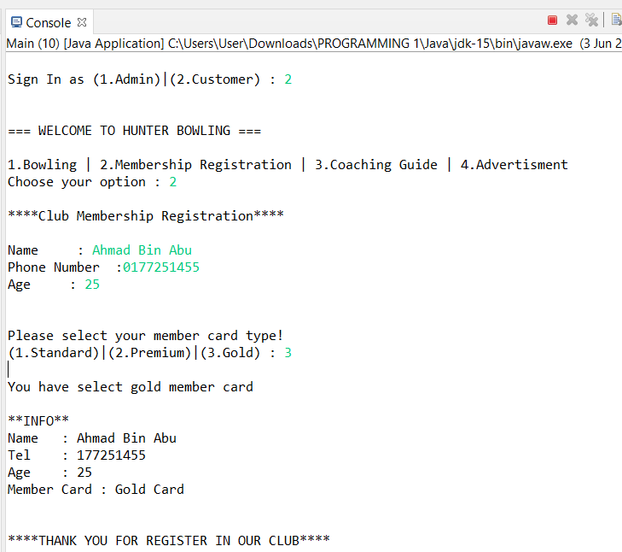

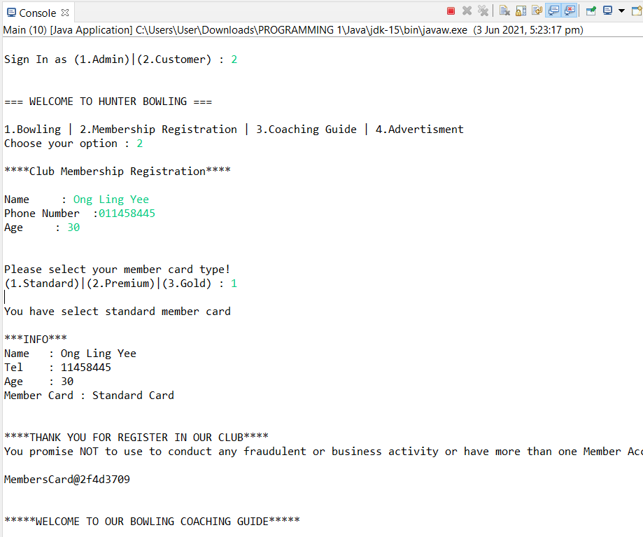

* Log in as “Customer” and go to “Coaching Guide” and choose “Training period 6 or 9 month” and choose “member card” to get discount price.

